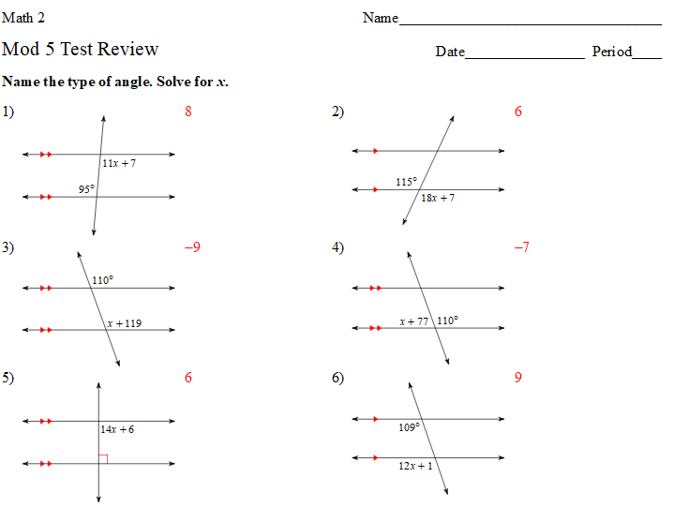
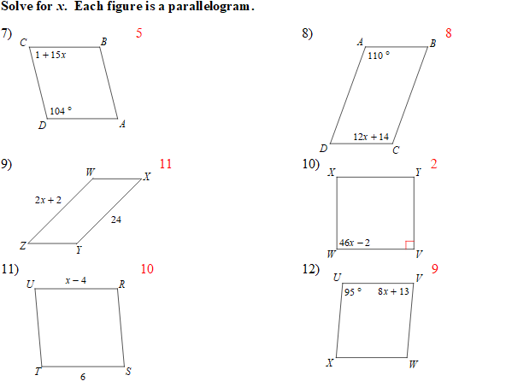
13. Find the value of $x$. Show your work.
4x + 11
x + 9

100

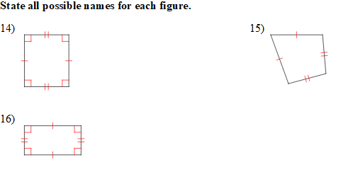
Use what you know about triangles and parallelograms to find each measure.
